Test for proportions
- Significance Level (α):
The significance level is the threshold for determining whether to reject the null hypothesis, commonly set at 0.05.
- Null Hypothesis (H0):
The null hypothesis states that the population proportion is equal to a specified value, e.g., H0: p=0.5 for a fair coin.
- Test Statistic (Z):
The test statistic is calculated to determine how far the sample proportion is from the null hypothesis proportion, standardized by the standard error.
- Alternative Hypothesis (H1):
The alternative hypothesis states that the population proportion is not equal to the specified value, e.g., H1: p≠0.5.
- P-value:
The p-value indicates the probability of observing the test statistic under the null hypothesis; a small p-value suggests rejecting H0.
- Central Limit Theorem:
The Central Limit Theorem states that the distribution of the sample proportion approaches a normal distribution as the sample size increases, under certain conditions.
This content was generated by AI, so please check for any mistakes.
In the videos, you learnt how to perform hypothesis testing for the mean of a Gaussian population. Another very useful example is testing for a population proportion $p$p.
An example
Imagine that you have a coin, but you don't know whether it's fair or not. The proportion you are interested in is $p=P(H)$p, equals, P, left parenthesis, H, right parenthesis. A possible set of hypothesis for this problem is
$H_{0}:p=0.5\text{ vs. }H_{1}:p≠0.5$H, start subscript, 0, end subscript, colon, p, equals, 0, point, 5, start text, space, v, s, point, space, end text, H, start subscript, 1, end subscript, colon, p, does not equal, 0, point, 5
Imagine you toss the coin $20$20 times, of which $7$7 turned out heads. Your random sample consists in one random variable $X=$X, equals"number of heads in $20$20 coin flips", which has a $Binomial(20,p)$B, i, n, o, m, i, a, l, left parenthesis, 20, comma, p, right parenthesis distribution. A good estimation for the proportion is the relative frequency of heads:
$\hat{p}=\frac{X}{20}$p, with, hat, on top, equals, start fraction, X, divided by, 20, end fraction
Remember that under certain conditions, the Central Limit Theorem states that $\hat{p}∼N(p,\sqrt{\frac{p(1-p)}{20}})$
p, with, hat, on top, \sim, N, left parenthesis, p, comma, square root of, start fraction, p, left parenthesis, 1, minus, p, right parenthesis, divided by, 20, end fraction, end square root, right parenthesis, or equivalently
$$Z=\frac{\frac{X}{20}-p}{\sqrt{p(1-p)}}\sqrt{20}∼N(0,1)$$
Z, equals, start fraction, start fraction, X, divided by, 20, end fraction, minus, p, divided by, square root of, p, left parenthesis, 1, minus, p, right parenthesis, end square root, end fraction, square root of, 20, end square root, \sim, N, left parenthesis, 0, comma, 1, right parenthesis
$Z$Z will be your test statistic. If $H_{0}$H, start subscript, 0, end subscriptis true $(p=0.5)$left parenthesis, p, equals, 0, point, 5, right parenthesis, then your test statistic becomes
$$Z=\frac{\frac{X}{20}-0.5}{\sqrt{0.5(1-0.5)}}\sqrt{20}=\frac{\frac{X}{20}-0.5}{0.5}\sqrt{20}∼N(0,1)$$
Z, equals, start fraction, start fraction, X, divided by, 20, end fraction, minus, 0, point, 5, divided by, square root of, 0, point, 5, left parenthesis, 1, minus, 0, point, 5, right parenthesis, end square root, end fraction, square root of, 20, end square root, equals, start fraction, start fraction, X, divided by, 20, end fraction, minus, 0, point, 5, divided by, 0, point, 5, end fraction, square root of, 20, end square root, \sim, N, left parenthesis, 0, comma, 1, right parenthesis
Consider a significance level $α=0.05$alpha, equals, 0, point, 05. Then to make a decision you need to get the p-value for your observed statistic. With the observed sample $x=7$x, equals, 7, the observed statistic is
$$z=\frac{\frac{7}{20}-0.5}{0.5}\sqrt{20}=-1.3416$$
z, equals, start fraction, start fraction, 7, divided by, 20, end fraction, minus, 0, point, 5, divided by, 0, point, 5, end fraction, square root of, 20, end square root, equals, minus, 1, point, 3416
The p-value is then the probability that $Z>∣z∣$Z, is greater than, vertical bar, z, vertical bar or $X<-∣z∣$X, is less than, minus, vertical bar, z, vertical bar:
$p\text{-value}=P(∣Z∣>∣z∣)=P(∣Z∣>1.3416)=0.1797$p, start text, negative, v, a, l, u, e, end text, equals, P, left parenthesis, vertical bar, Z, vertical bar, is greater than, vertical bar, z, vertical bar, right parenthesis, equals, P, left parenthesis, vertical bar, Z, vertical bar, is greater than, 1, point, 3416, right parenthesis, equals, 0, point, 1797
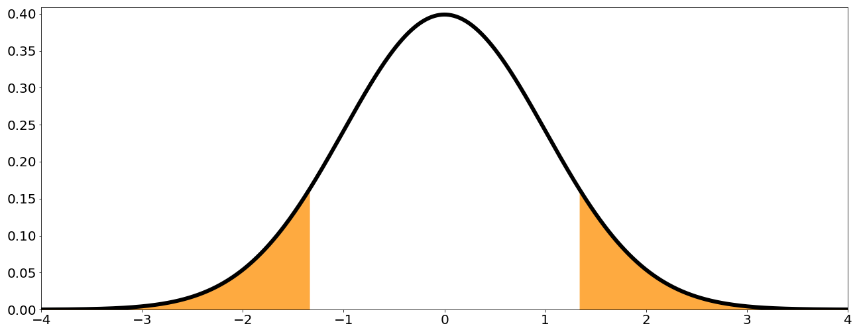
Conclusion: since the p-value is bigger than the significance level of 0.05, you do not have enough evidence to reject the null hypothesis that $p=0.5$p, equals, 0, point, 5.
General case:
- $p$p is the population proportion of individuals in a particular category (i.e. probability of the coin landing heads)
- $p_{0}$p, start subscript, 0, end subscript is the population proportion under the null hypothesis (i.e. $p_{0}=0.5$p, start subscript, 0, end subscript, equals, 0, point, 5)
- $x$x is the observed number of individuals in the sample from the specified category (i.e. number of heads)
- $n$n is the sample size (i.e. number of coin toss)
- $\hat{p}=\frac{x}{n}$p, with, hat, on top, equals, start fraction, x, divided by, n, end fraction is the sample proportion for the observed sample $x$x.
Then, $Z=\frac{\frac{X}{n}-p_{0}}{\sqrt{p_{0}(1-p_{0})}}\sqrt{n}∼N(0,1)$
Z, equals, start fraction, start fraction, X, divided by, n, end fraction, minus, p, start subscript, 0, end subscript, divided by, square root of, p, start subscript, 0, end subscript, left parenthesis, 1, minus, p, start subscript, 0, end subscript, right parenthesis, end square root, end fraction, square root of, n, end square root, \sim, N, left parenthesis, 0, comma, 1, right parenthesis is the test statistic for comparing proportions, and $z=\frac{\frac{x}{n}-p_{0}}{\sqrt{p_{0}(1-p_{0})}}\sqrt{n}$
z, equals, start fraction, start fraction, x, divided by, n, end fraction, minus, p, start subscript, 0, end subscript, divided by, square root of, p, start subscript, 0, end subscript, left parenthesis, 1, minus, p, start subscript, 0, end subscript, right parenthesis, end square root, end fraction, square root of, n, end square root is the observed statistic. Depending on the type of hypothesis, you have different expressions for the p-value:
- Right-tailed test: $H_{0}:p=p_{0}\text{ vs. }H_{1}:p>p_{0}$H, start subscript, 0, end subscript, colon, p, equals, p, start subscript, 0, end subscript, start text, space, v, s, point, space, end text, H, start subscript, 1, end subscript, colon, p, is greater than, p, start subscript, 0, end subscript : $p\text{-value}=P(Z>z)$p, start text, negative, v, a, l, u, e, end text, equals, P, left parenthesis, Z, is greater than, z, right parenthesis
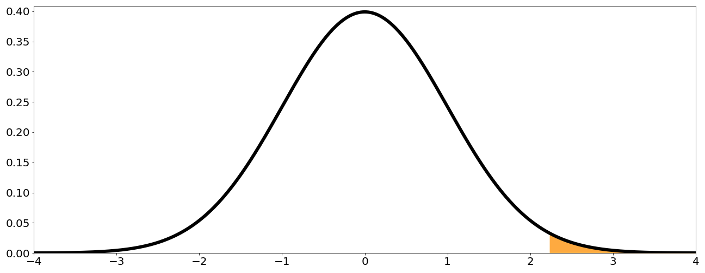
- Left-tailed test: $H_{0}:p=p_{0}\text{ vs. }H_{1}:p<p_{0}$H, start subscript, 0, end subscript, colon, p, equals, p, start subscript, 0, end subscript, start text, space, v, s, point, space, end text, H, start subscript, 1, end subscript, colon, p, is less than, p, start subscript, 0, end subscript $p\text{-value}=P(Z<z)$p, start text, negative, v, a, l, u, e, end text, equals, P, left parenthesis, Z, is less than, z, right parenthesis
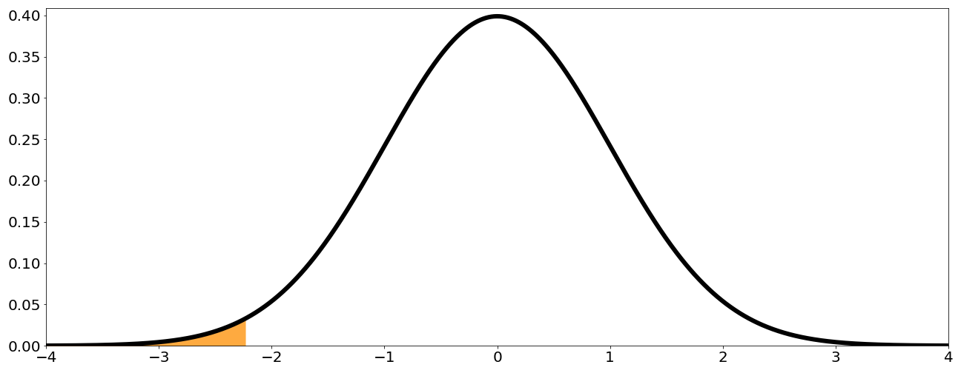
- Two-tailed test: $H_{0}:p=p_{0}\text{ vs. }H_{1}:p≠p_{0}$H, start subscript, 0, end subscript, colon, p, equals, p, start subscript, 0, end subscript, start text, space, v, s, point, space, end text, H, start subscript, 1, end subscript, colon, p, does not equal, p, start subscript, 0, end subscript $p\text{-value}=P(∣Z∣>∣z∣)$p, start text, negative, v, a, l, u, e, end text, equals, P, left parenthesis, vertical bar, Z, vertical bar, is greater than, vertical bar, z, vertical bar, right parenthesis
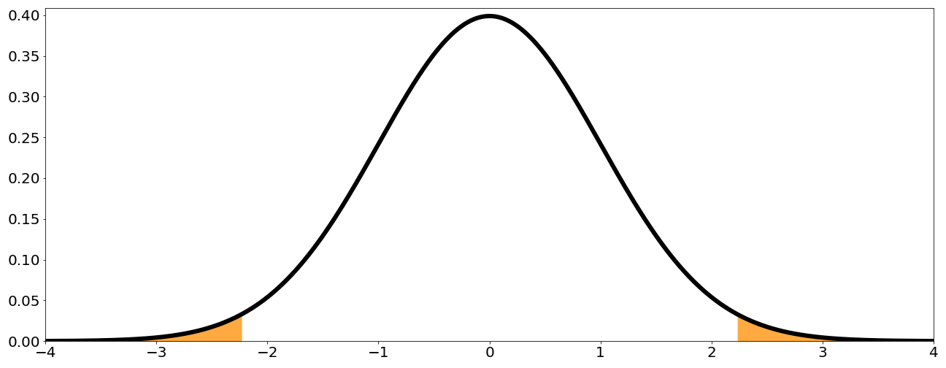
For this results to be valid, the following conditions need to be satisfied:
- The population size needs to be at least 20 times bigger than the sample size. This is necessary to ensure that all samples are independent. This condition is not needed in situation like the coin toss, where independence is inherent to the experiment.
- The individuals in the population can be divided into two categories: whether they belong to the specified category or they don't
- The values $np_{0}>10$n, p, start subscript, 0, end subscript, is greater than, 10 and $n(1-p_{0})>10$n, left parenthesis, 1, minus, p, start subscript, 0, end subscript, right parenthesis, is greater than, 10. This condition needs to be verified so that the Gaussian approximation holds when the assumption that $H_{0}$H, start subscript, 0, end subscript is true.

